MANUAL FOR PURCHASE OF FSC CERTIFIED AND LABELLED PRODUCTS
[INSERT NAME OF LICENSE HOLDER] holds an FSC promotional license in accordance with “FSC® Trademark - Use Guide For Promotional Licence Holders”. To be qualified for FSC promotion a forest-based product must be FSC labelled and supplied directly from a FSC certified supplier that states the product’s FSC-claim and supplier’s own CoC code on invoices. To ensure this the following actions must be carried out by the supplier and purchaser:

Checklist for buyers of FSC-certified products:
- Verify that our direct supplier is FSC-certified
- Verify that the supplier is aware of requirement of FSC-certified and labelled products
- Verify that the product is FSC-labelled
- Confirm that invoices include CoC-code and FSC-claim(s)
- Provide documentation at the yearly license control performed by FSC Danmark

Verify that our direct supplier is FSC-certified
- The direct supplier is FSC CoC certified and has provided purchaser link to online certificate information (info.fsc.org) and/or certificate in pdf
- Using info.fsc.org the purchaser has verified, that a) the suppliers’ certificate is valid and issued to the supplier and b) the relevant product type, species (if relevant) and a FSC claim (FSC Mix, FSC 100% or FSC Recycled) is listed in the certificate’s online product information (info.fsc.org)
Verify that supplier is aware of requirement of FSC-certified and labelled product(s)
- The direct supplier is aware about the requirements – e.g. the requirement is included in purchase contracts, business agreements, purchase order or alike
- The requirement can be specified as:
  - supplier invoice must contain FSC claim for the product and supplier’s certificate code
  - the product is delivered FSC-labelled (on the product, it’s packaging or hang-tag)

Verify that the product is FSC-labelled
- The direct supplier has provided proof/documentation that the product is FSC labelled (e.g. through specification in purchase contract or alike or by access to artwork / product images) and this is verified by the purchaser
- The purchaser keeps documentation for products’ FSC labelling

FSC labels (generic, for illustration only)
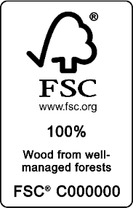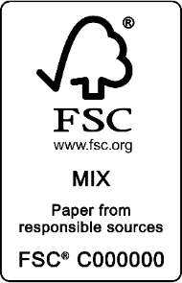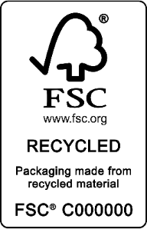

Confirm that invoices include CoC-code and FSC-claim(s)
- The purchaser has verified that the invoice concerning the FSC certified product contain:
  - FSC-claim for the FSC-certified product (FSC 100%, FSC Mix or FSC Recycled)
  - FSC CoC code of the certified supplier
- The purchaser keeps records of invoices with FSC-claims and CoC-code

Provide documentation at the yearly license control performed by FSC Denmark
- The purchaser provides FSC Denmark examples of invoices, documentation of product’s FSC-labelling and link to supplier’s certificate in info.fsc.org during the yearly license control (performed as desk audit). Sensitive information can be crossed out or alike.

IN DOUGHT? Ask Purchase/compliance Department

